Battling Kleine-Levin syndrome, Georgia Green can sleep for 10 days without waking properly
August 24, 20151:11pm
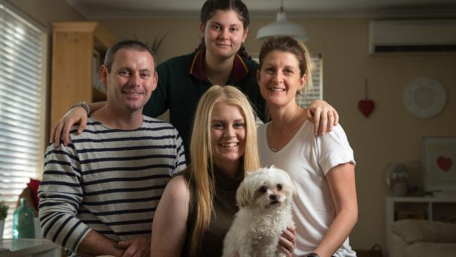
Georgia Green flanked by her parents Damien and Anna and sister Louisa, 16, and their dog Bella at their Flagstaff Hill home. Picture: MATT TURNER
KATRINA STOKESSunday Mail (SA)
IMAGINE going to sleep, waking up and more than a week has passed.
You’ve missed school exams, Christmas, New Years and your sister’s birthday.
Only this isn’t a dream — this is Georgia Green’s life.
The 19-year-old is Adelaide’s Sleeping Beauty, lives with Kleine-Levin syndrome, a one in a million sleep disorder which means she sleeps without waking properly for up to 10 days at a time.
“I feel like you do when you’re really, really drunk, when you’re at that point in the night when you don’t know what’s happening,” she said, adding she has literally lost months of her life over the past few years.
“It’s a really foggy sort of feeling in your head and that’s how I know that an episode is coming on.
“Then I feel really tired and just want to go to bed — I’m knocked out.”
Georgia, of Flagstaff Hill, has regular “episodes” where she sleeps for 12-to-18 hours a day.
The rest of the time she is in a sleep-walk state, unable to make conversation and only getting out of binge eat and go to the toilet.
Georgia estimates she has endured about 35 episodes, which means she has “lost” nearly a year of her life sleeping.
A perfectly normal child, the episodes started without warning when she was about 15.
She would be struck down once a month for ten days. After the first episode doctors put Georgia’s tiredness down to being a regular teenager but decided to thoroughly test her.
She had blood tests, she was put on the pill and given iron and immune booster tablets, she had MRI and brain scans. But nothing was conclusive.
There were more tests until Dr Mark Pertini, the head of the Women’s and Children’s Hospital Department of Psychological Medicine, wrote to Georgia’s paediatrician in May 2013 stating the “most likely working hypothesis” was she had Kleine-Levin syndrome.
“The best thing for me was getting the diagnosis so I can tell people that I’ve actually got something,” Georgia said.
Not only does Georgia live in a state of “fogginess” for days at a time, she also battles cravings for junk-food during her bouts of prolonged sleep.
“I really crave chocolate, lollies and chips and I don’t crave that stuff when I’m normal either,” she said.
Georgia quit Year 12 after regular episodes made her miss important school work and exams.
Today she works as a sales assistant in a shoe store and is studying a Bachelor of Disability at Flinders University.
It seems as though sufferers can grow out of the condition by their 30s.
Her mother Anna said her daughter’s condition has affected the family.
“She basically just shuts down, you can’t call her, she doesn’t answer texts — it’s scary sometimes,” she said.
“She’s got a good network around her so if it does continue then so be it (but) it’s like anybody with an illness, you just need to learn how to manage it the best way you can and we’ll get through it.”
Georgia is looking forward to the day when life is back to normal.
“There’s no treatments, there’s no cure, there’s no medicine, there is nothing to stop it being less severe, there is nothing to stop me from going into an episode,” she said.
“You’ve got to put everything aside and just deal with it.”
katrina.stokes@news.com.au
WHAT IS KLEIN-LEVIN SYNDROME
— Kleine — Levin syndrome (KLS) or “Sleeping Beauty syndrome” is a rare neurological sleep disorder which affects one in a million people.
— The condition was named after German neurologist Will Kleine, and US psychiatrist Max Levin who identified patients with similar symptoms in 1925 and 1936.
— KLS effects adolescents primarily but can occur in young children and adults.
— Little is known about the syndrome, but sufferers experience sleep “episodes” which last days, weeks and in some cases even months.
— There is no cure or treatment for KLS.
— Symptoms generally cease by the time people reach their 30s
SOURCE: News.COM.AU

